**Project**

**JSPR-Techies**

**Product Backlog  
  
10/26/2023**

**Members**

Jayani Sumanka Gerine

Pallavi Dabade

Raksha Varahamurthy

### Surya Subramani

**Table of Contents**

Project Title & Members………………………………………………….1

Fibonacci number scale………………………………………………….3

Refined List of User Stories……………………………………………...4

Breakdown of Large User Story…………………………………………7

Product Backlog…………………………………………………………...8

User Stories for First Iteration……………………………………………9

Partially Implemented Functionality……………………………………..9

User Interface Design Sketches………………………………………..10

**Fibonacci Number scale for User Stories**

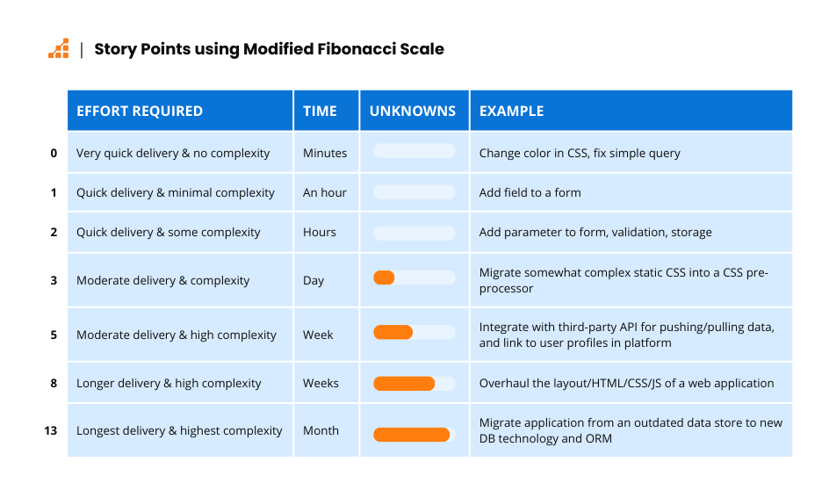

**Fibonacci numbers to size User Stories:**

### **0** – Very quick to deliver and no complexity. In minutes

### **1** – Quick to deliver and minimal complexity. An hour

### **2** – Quick to deliver and some complexity. Multiple hours

### **3** – Moderate time to deliver, moderate complexity, possible unknowns

### **5** – Longer time to deliver, high complexity, likely unknowns

### **8** – Long time to deliver, high complexity, critical unknowns

### **13** – Long time to delivery, high complexity, many critical unknowns

### **21** – You’re doing this wrong.

**Refined List of User Stories**

1. **User Login - New User (Sign Up) Size: 5**

User Role : Student, Faculty and Alumni of University of Michigan

Goal : User access the JSPR-Techies blog and landed on Login page

Reason : User can access blog if they are associated with University of Michigan

Preconditions: User access the blog using domain name

Postcondition: User create account using unique name as username and email as password

1. **User Story - User Login - Existing User Size: 5**

User Role : Student, Faculty and Alumni of University of Michigan

Goal : User access the JSPR-Techies blog and landed on Login page

Reason : User can access blog if they are associated with University of Michigan

Preconditions: User access the blog using domain name

Postcondition: User must enter unique name as username and email as password

1. **User Story - Landing Page after User Authentication Size: 3**

User Role : Student, Faculty and Alumni of University of Michigan

Goal : User access the JSPR-Techies blog and landed on Home page

Reason : User can access blog if they are associated with University of Michigan

Preconditions: User should be successfully logged into JSPR- Techblog after user is authenticated.

Postcondition: User can view the welcome message

1. **User Story - Search Articles Size: 13**

User Role : Student, Faculty and Alumni of University of Michigan

Goal : User should be able to search relevant articles

Reason : User can access top 5 articles according to his preference

Preconditions: User should enter keywords for search.

Postcondition: User should click on submit button

1. **User Story - Display List of Article Size: 8**

User Role : Student, Faculty and Alumni of University of Michigan

Goal : User should be able to view the list of articles based on the search criteria

Reason : User can access top 5 articles according to his preference

Preconditions: User should enter keywords and click enter.

Postcondition: User should be able to view a list of articles.

1. **User Story - View Article from the list of articles Size: 3**

User Role : Student, Faculty and Alumni of University of Michigan

Goal : User should be able to search relevant articles

Reason : User should be able to read articles

Preconditions: User should be able to click on specific article to read

Postcondition: User should be able to read articles

1. **User Story - Create Database Size: 8**

User Role : Developer

Goal : Build database and table

Reason : Technical requirement

Preconditions: Database model define

Postcondition: Retrieve the article data from database.

1. **User Story - Create API Flask [Front End - python , html , css ] Size: 8**

User Role : Developer

Goal : Application Programming Interface where users can log in and access the articles.

Reason : Technical requirement

Preconditions: Use Flask to build an API

Postcondition: Users can access on frontend the articles.

**9. User Story - Establish Mysql connection database to API Size: 5**

User Role : Developer

Goal : To search the user defined keyword in database

Reason : Technical requirement

Preconditions: Article table defined

Postcondition: Established connection will allow users to interact with application and access the articles.

**10. User Story - Document Ranking** - NLP task **Size: 8**

User Role : Developer

Goal : Recommend top 5 articles to user

Reason : Technical requirement

Preconditions: Ranking algorithm calculated to suggest top 5 articles to users.

Postcondition: Users will be able to access those articles for defined keywords.

**Break down of previously identified large user stories:**

We identified that our “Search Articles” user story is a large one and hence decided to divide it into the following subset user stories.

**11. User Story: Search Initiation**  **Size: 3**

User Role : Student, Faculty and Alumni of University of Michigan.

Goal : Users should be able to enter search keywords.

Reason : Users can access top 5 articles according to the keyword entered.

Preconditions: Users should be logged into the JSPR- Techblog.

Postcondition: User should click on the submit button.

**12. User Story: Search Recommender**  **Size: 3**

User Role : Developer

Goal : Recommend top 5 articles by matching entered keyword to AI model

Reason : Users can access top 5 articles according to the keyword entered.

Preconditions: User should have entered keyword to initiate search

Postcondition: Recommended articles will be returned.

**13. User Story: Search Visualization** **Size: 3**

User Role : Student, Faculty and Alumni of University of Michigan.

Goal : Top 5 articles recommended by AI model will be displayed for the user in the recommended articles page

Reason : Users can access top 5 articles according to the keyword entered.

Preconditions: Search recommenders should have identified articles matching search keywords.

Postcondition: User should be able to click on the required article from the list of articles.

**Product Backlog Screenshot From Jira**

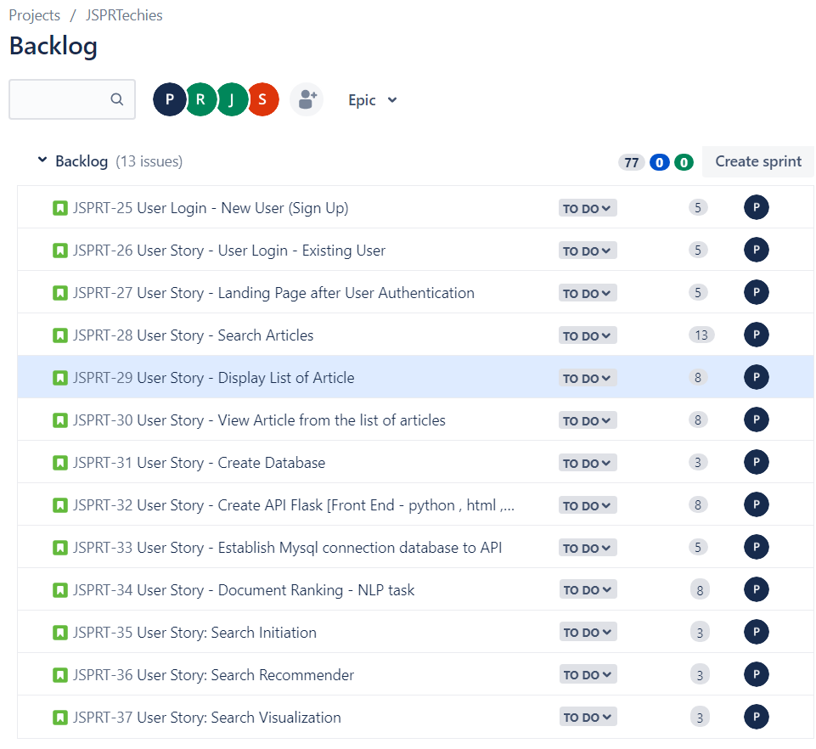

**List of User Stories for the first iteration 10/27/23 to 11/10/23**

1. User Story - Create Database
2. User Story - Create API Flask [Front End - python , html , css ]
3. User Story - Establish Mysql connection database to API

**Partially implemented functionality after first iteration**

* The project framework and database foundation will be ready.
* Database connection to API will be established.

**User Interface Design Sketches**

*A prototype video which explores all functions of the UI is attached along with this pdf file in Canvas or you can see using this youtube video link* [*https://youtu.be/YJV2yB5oUUw.*](https://youtu.be/YJV2yB5oUUw.)

